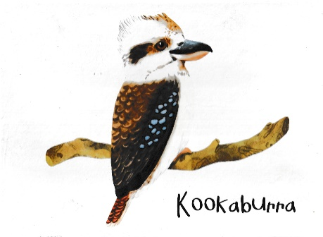

Options for Covid 19 affected weddings at The Wedding Shed, Kookaburra Hideaway

August 26th, 2021

Based on the questions we have received so far from clients and the solutions we have found for them, here is a Question and Answer Sheet that we hope helps.

Q. Have the Covid 19 restrictions affected any upcoming weddings for 2021?
A. So far all our weddings from the end of July through to 1st week of October 2021 have been postponed to later dates in 2022.

Q. If weddings are allowed to go ahead with some restrictions, can we get an idea of the capacities of the venue for a 4sqm/per person and a 2sqm/per person reception so we can start preparing a cut down guest lists as necessary?

A.The Square meterage of our marked out floor area is 520 sq metres. However, we are considered to be an outdoor/indoor venue as we do not have solid doors or walls between outside and inside. That means, using just the indoor floor space and the artificial turf area only, for a 4sqm rule we could have up to 130 and for 2sqm that would be 70 persons.

Because we also have uninterrupted outdoor space around the marked out area indoor and floor area; including the Boho Area and the area behind it, we can also have extra persons so long as it was considered safe and complies with regulations. That said, our preference at the moment is for weddings under 100.

Q. In the event that small weddings are allowed, what does the marry now party later option entail? How many people are normally present at a ceremony like this? and then how do we select the date for the "party later" part?

A. With last year's Covid small weddings with just 5 persons total including bride, groom and Celebrant were allowed. There was a lot of protest about that however as it meant that the marrying couple could only choose 2 friends or family to attend. I really don't know how many will be allowed at "small weddings" but I am hoping it will be at least 10.

I (Val) did a few marry now/party later weddings last year. The way it works is that I officially marry the couple on the day of their planned wedding, or another chosen date, usually in the morning. Then at a future date of their choice the marrying couple have their party/reception to celebrate with all their family and friends and at that time, free of charge, I conduct a renewal of vows ceremony, using similar wording to their actual wedding ceremony conducted previously.

At the small wedding, some couples got married in their wedding outfits, even if they couldn’t have their bridal party with them and some just got married in normal attire and saved the wedding outfits for the reception/party.

After the small ceremony some couples went to brunch, lunch or dinner, some just had some champagne/drinks at the Marrying Tree (we can set up for you).

The party later wedding/reception would be the same price as your current wedding. The 3% surcharge for 2022 and 5% for 2023 would be waived.

Q. In the absolute worst-case scenario, if the current restrictions remain the same and no weddings are allowed, are there any fees associated with postponing to a new date?

A. As per the party later wedding/reception, a postponed date would be the same price as your current wedding. The 3% surcharge for 2022 and 5% for 2023 would be waived.

There is no set notice period for postponing a wedding, however generally at least a month's notice is desirable, especially as we may be able to offer your date to another couple having a smaller wedding.

We hope this helps you with your planning. Please contact us if you need any further information or dates.

Val and Andrew
The Wedding Shed @ Kookaburra Hideaway
weddingshq@gmail.com

