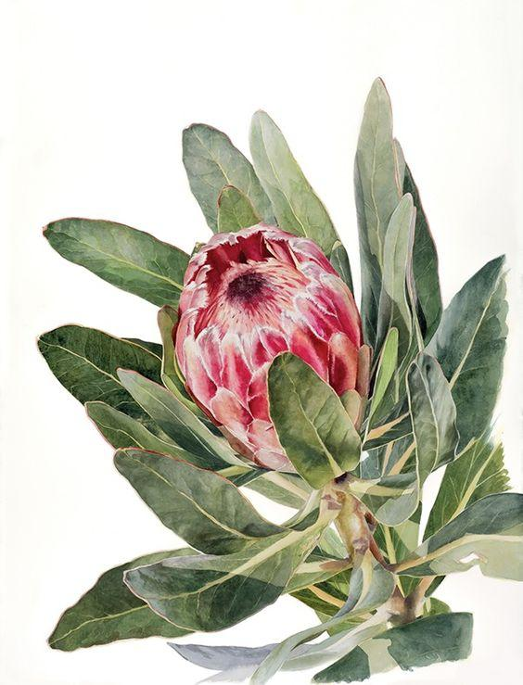

The Marriage of Marrying partner and Marrying partner
Kookaburra Hideaway
Date:
3pm April – October
4pm October – April
Changeover in accordance with Daylight Saving
Please do not select other times for Ceremony without speaking to venue as extra charges may apply.

Ceremony Location
Colour Scheme

Guest numbers:
Celebrant:
Bride and Groom or marrying couple:
Wedding Party Names please:
Parents of the Marrying Partner 1
Parents of the Marrying Partner 2

Wet weather options…Courtyard at Kookaburra Hideaway or inside Wedding Shed…

Actions:- Do you want unplugged?

Approx 5-10 mins before walkdown time all guests sit/stand in ceremony area…

Val to make Housekeeping announcement prior to bride arrival.

“On the day Co-ordinator” will Supervise Marrying partner’s walkdown from Bridal Suite..

The Wedding Shed will provide speaker and music player for your entry music. Please supply a guest to “press play” on your/their phone. Make sure they have your playlist…

Please note, if Val is your Celebrant she will conduct a rehearsal for you on day before your wedding at 3pm or 4pm depending on your ceremony time so that to go through your ceremony and have any other discussions we need..

The Wedding Ceremony –

Conducted by Valerie Haydon, Authorised Celebrant

Introduction – Val

Friends and Family welcome to this special occasion, the day when Marrying partner and Marrying partner take each other’s hand and begin their life together as Husband and wife, Partners for life, Bride and Bride or husband and husband.. or other.

My name is Valerie Haydon and I am an authorised Marriage Celebrant. I call upon the persons here present to be a fellow witness with me in their marriage.

Marrying partner and Marrying partner are so happy to have you here with them today and they are incredibly grateful to have you in their lives.

They would especially like to thank…………………. And also thank those who have travelled to come and help them celebrate their very special day.

So let’s start with the story of how they met –

Your story

Where/how you met-

Your story

The Proposal-

Val says…

So Marrying partner and Marrying partner, no matter how long you have been together as partners, just know this… Being married makes a difference. It’s the missing piece in the jigsaw… it takes away the “what if” and changes it to “we are”.

Today you are pledging your love and devotion to one another and creating a safe haven for you to build on for you, your family and your loved ones over the years to come.

This is the beginning of wonderful marriage, based on friendship, love and trust and all of us here today wish you all the happiness and love in the world.

Celebrant’s Monitum, must be said verbatim, not changeable.

I, Valerie May Haydon, a Civil celebrant am duly authorised to solemnise marriages according to law.
Before you are joined in marriage in my presence and in the presence of these witnesses, I am to remind you of the solemn and binding nature of the relationship into which you are now about to enter. Marriage, according to law in Australia, is the union of two people to the exclusion of all others, voluntarily entered into for life.

The Asking by Val:

Marrying partner. Do you take Marrying partner to be your lawful wedded wife?
From this day onwards, whether in good times or bad, do you promise to love her, honour her, support her and be there for her for the rest of your life?

Marrying partner: I do

Marrying partner:
Marrying partner. Do you take Marrying partner to be your lawful wedded husband?
From this day onwards, whether in good times or bad, do you promise to love him, honour him, support him and be there for him for the rest of your life?

Marrying partner: I do

The Official Vows..

Marrying partner:
I, Marrying partner
take you Marrying partner as my lawful wedded wife.
I promise to love you, to be your best friend, to respect and support you, to be patient with you, to work together with you to achieve our goals and to share my life with you.

Followed by

I, Marrying partner take you Marrying partner
as my lawful wedded husband. I promise to love you, to be your best friend, to respect and support you, to be patient with you, to work together with you to achieve our goals and to share my life with you.

PERSONAL VOWS to be said after official vows

Are you saying personal vows to one another? Yes.. please make sure you bring with you.

Marrying partner Vows to Marrying partner

Marrying partner Vows to Marrying partner

Exchanging of Rings Who has the rings ?

Place ring on tip of Marrying partner’s finger and Repeat after Val..

Marrying partner to Marrying partner
Marrying partner, with this ring I marry you. May it be a reminder of the love and commitment I have made to you today and pride that you are my wife/husband/partner for life

Please ring on tip of Marrying partner’s finger and Repeat after Val..

Marrying partner to Marrying partner
Marrying partner, with this ring I marry you. May it be a reminder of the love and commitment I have made to you today and pride that you are my wife/husband/partner for life

Declaration of Marriage - Celebrant to the guests:
Marrying partner and Marrying partner have declared before all of us that they will live together in marriage. They have made special promises to each other. They have symbolised it by taking vows, exchanging rings and declaring their eternal love for one another.
So therefore, by the powers vested in me by the Commonwealth of Australia, I now declare them to be husband and wife.

You may kiss your bride😊 Applause
Please advise witness full names including middle names

Val presents the new married couple to the congregation.…
Ladies and gentlemen, it now gives me great pleasure to present,
Please let me know how you want to be announced.

The new Mr and Mrs ? Mrs and Mrs, Mr and Mr…… Marrying partner and Marrying partner, husband and Wife or anything else you would like me to say.

